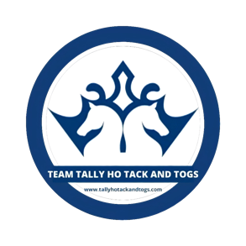
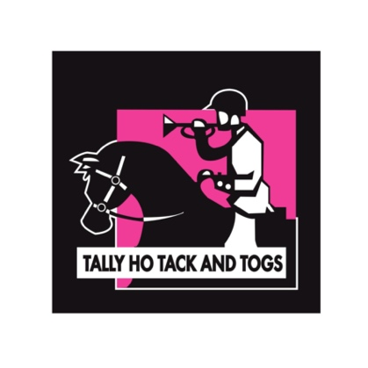

Apply to join the winning team
Team Tally Ho Tack and Togs
Powered by
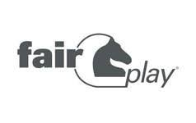

What we’re looking for. High profile riders across all equestrian disciplines. Here’s a checklist of what we look for.
- Consistent social media posters/bloggers.
- Consistent competitors with proven track records. You must be a regular on the circuit countrywide with great results and placing’s
- You must NOT be sponsored by any other equestrian retailer or clothing brand.
- Shortlisted riders will be contacted to discuss what we require from team members and how we reward our riders.

Complete the form in full and return to tallyhotacktogs@aol.com

NAME………………………………………………………………………………………………………………….
ADDRESS……………………………………………………………………………………………………………
…………………………………………………………………………………………………………………………….
TEL NO…………………………………………………………
EMAIL…………………………………………………………..
D.O.B…………………………………………………………….
DISCIPLINE (showjumping/dressage/eventing…………………………………………
SOCIAL PLATFORMS (your pages etc)……………………………………………………….
EMPLOYMENT DETAILS……………………………………………………………………………...

Tell us all about you, your horses, your achievements and goals. List your competitions in 2021/results and upcoming calendar.

Why Should we choose you? What makes you a good fit for the team?

The team is powered by fairplay, tell us what you love about the brand and why you and your horses will represent fairplay favourably and grow brand awareness?

Feel free to add as much information as you like. We like to see profile pics of you and your horse and some of your social posts.
